**[Griffiths](https://docs.google.com/document/d/1Hmlp39B4ErLKe3b8TO1vQpZW5r9T0sCYiy9b404jAr8/edit?usp=sharing) et al,**

**FIGURE 1**. A) Study site at Calvert Island BC. B) Choked pass, site of experimental transplants and surveys of *Smithora* *naiadum* and *Zostera marina.* Twelve sites in the meadow were surveyed using 40 m transects. *Smithora* abundance (biomass? Visually estimated abundance?) on *Z. marina* at each sampled site is represented by red circles. C) Smithora biomass / Zostera biomass at edge vs interior (circled) sites (n = 4). The site of the reciprocal transplant is WF (lower left).

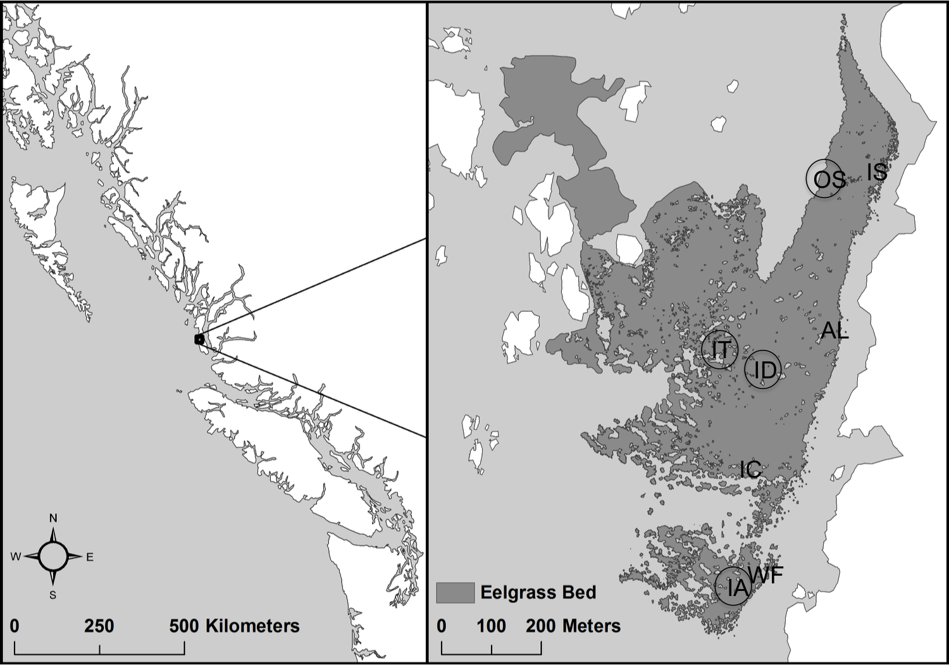

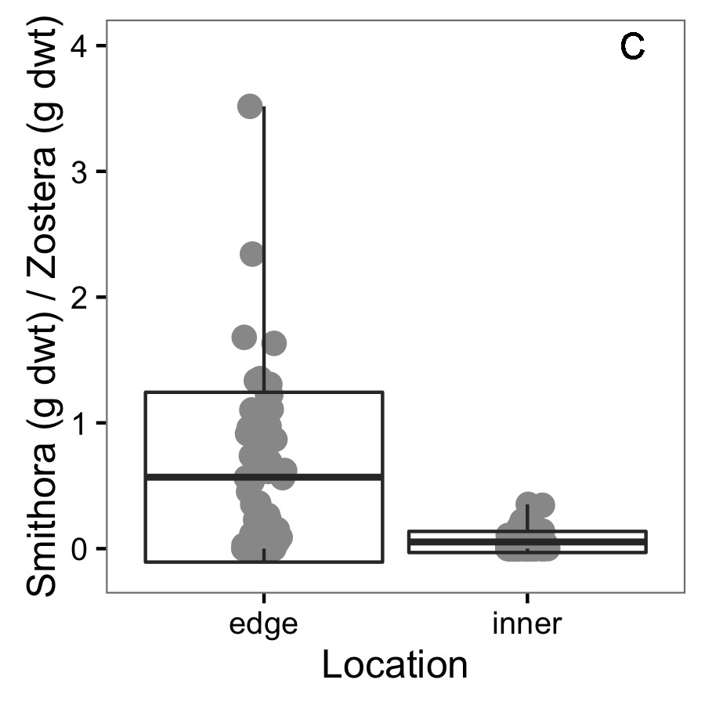

**Figure 2.** Conditions at the two experimental transplant sites (WF and IA) before the experiment in June 2017. For six replicate samples of 0.0625 m2 of seagrass meadow, A) *Z. marina* dry weight of above ground biomass, B) *Smithora* dry weight biomass (per *Z. marina* shoot biomass) C) grazer abundance / X g shoots, and D) seagrass surface bacterial assemblages varied significantly. See appendix for grazer composition comparison.

**Adjusted designation of one interior quadrat at position 0. The spot actually curved around so it was actually more of an edge location. Let me know if this is ok!

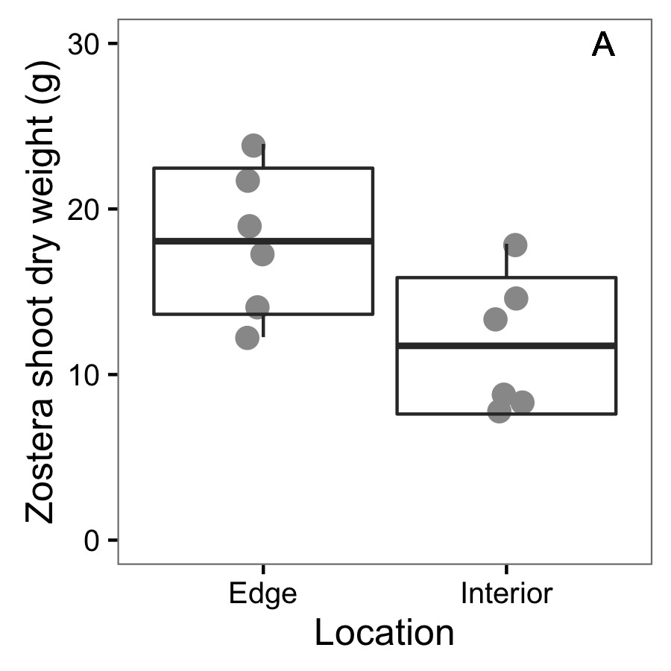 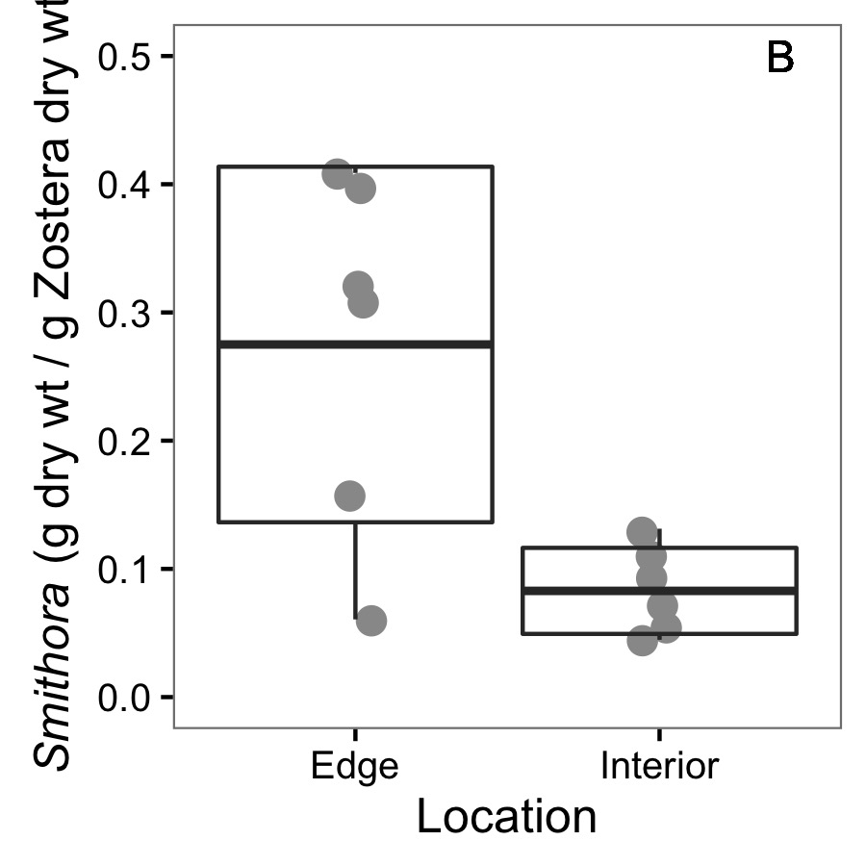

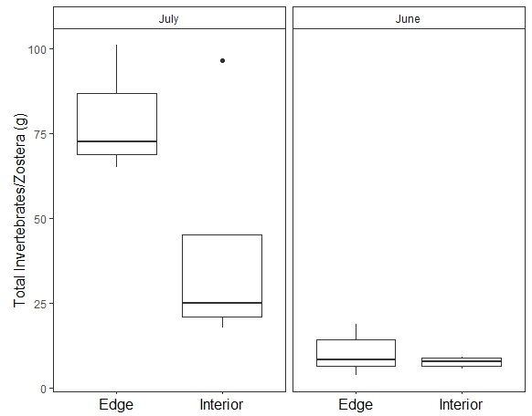

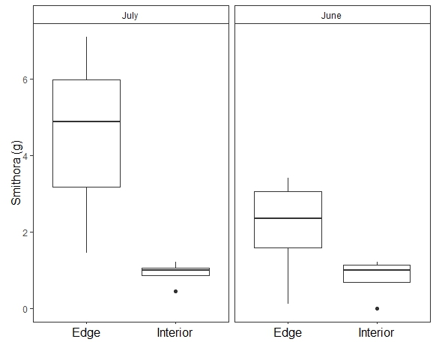

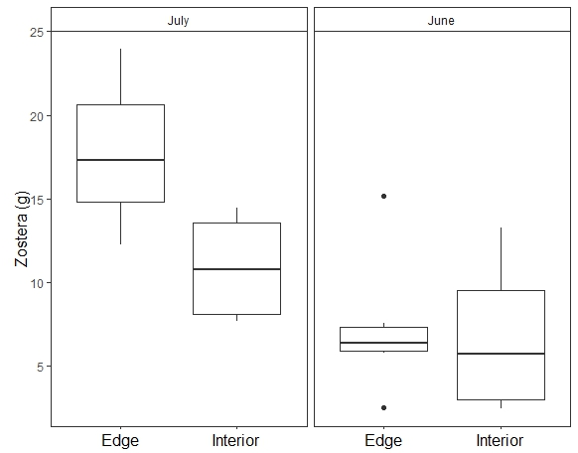

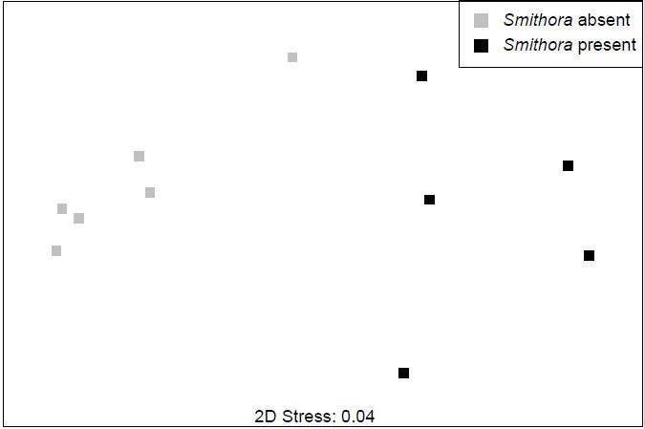

Bacterial communities before transplant.

**Figure 3**. Final *Smithora* abundance (g / g *Zostera* dry wt) for experimental and control shoots in the reciprocal transplant experiment. Box indicates mean and 1 standard deviation.

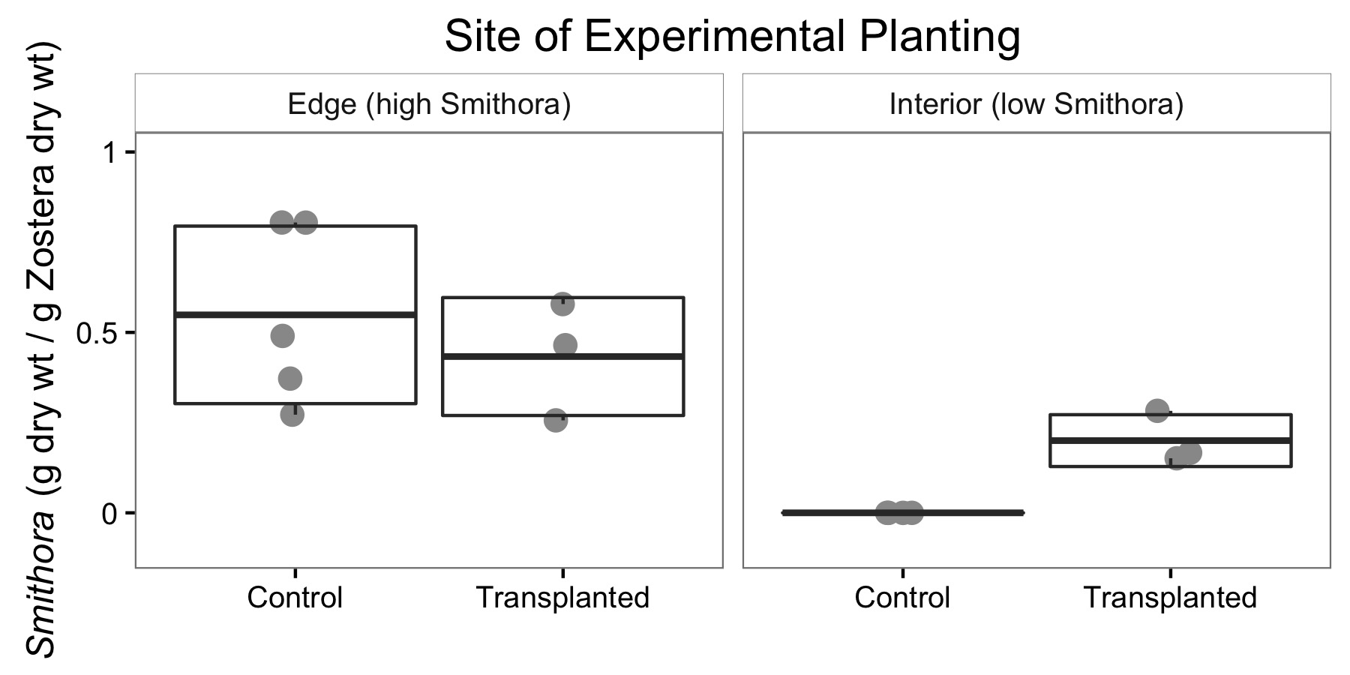

**Figure 4**. Bacterial assemblages after transplant with treatments indicated.

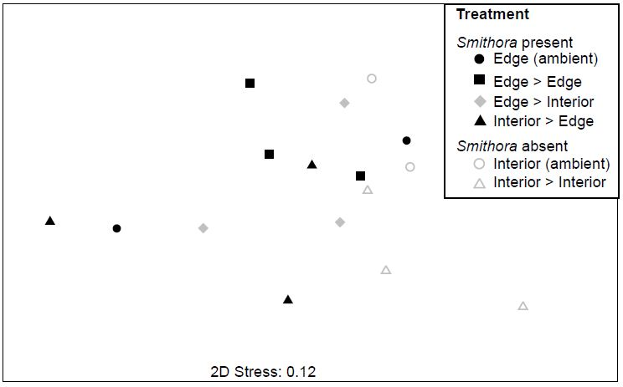

**APPENDIX:**

Figure A1: *Zostera marina* shoot density at transplant sites.

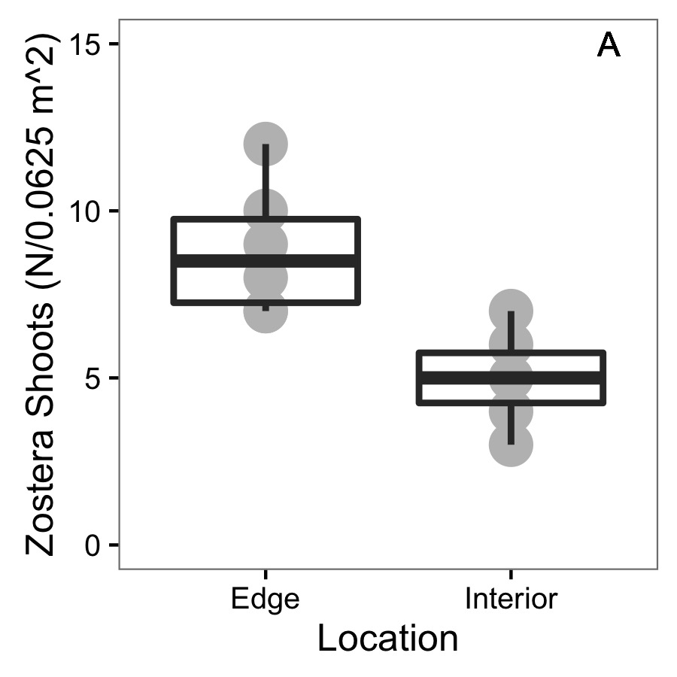

Figure A2: NMDS for grazer assemblages at transplant sites before experiment. Red hull is interior and grey hull is edge. Stress is 0.2873149. 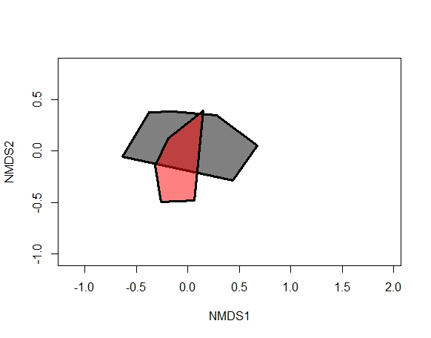

Figure A3: NMDS for grazer assemblages at transplant sites before experiment. Red hull is June and grey hull is July. Stress is 0.2873149.

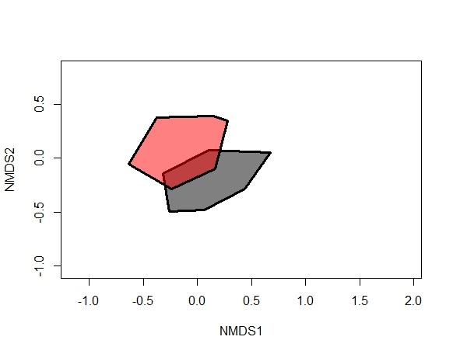

Figure A4. Bacterial composition plots grouped to order.

